AKSHAY N. VANJARE

Applied Statistics

Roll No. 2

Factor Analysis

Q. Perform Factor Analysis for given dataset.

Ans.

Code

path<-file.choose() # Factor file

df1<-read.table(path, header = T)

df<-df1[,-1]

#install.packages("psych")

library(psych)

KMO(df)

PC1<-principal(df, nfactors = 3, rotate = "varimax", cov =)

FA1<-factanal(df, 3, rotation = "varimax")

plot(PC1)

screeplot(princomp(cov(df)), type = "line")

biplot.psych(PC1)

FA1$factors

FA1$uniquenesses

FA1$n.obs

FA1$dof

FA1$method

FA1$call

FA1$rotmat

**OUTPUT**

> path<-file.choose() # Factor file

>

> df1<-read.table(path, header = T)

>

>df<-df1[,-1]

>

> #install.packages("psych")

> library(psych)

>

> KMO(df)

Kaiser-Meyer-Olkin factor adequacy

Call: KMO(r = df)

Overall MSA = 0.66

MSA for each item =

V1 V2 V3 V4 V5 V6

0.62 0.70 0.68 0.64 0.77 0.56

>

> PC1<-principal(df, nfactors = 3, rotate = "varimax", cov =)

>

> FA1<-factanal(df, 3, rotation = "varimax")

>

> plot(PC1)

>

>screeplot(princomp(cov(df)), type = "line")

>

>biplot.psych(PC1)

>

> FA1$factors

[1] 3

>

> FA1$uniquenesses

V1 V2 V3 V4 V5 V6

0.02560291 0.49240065 0.12304294 0.31937250 0.22582842 0.00500000

>

> FA1$n.obs

[1] 30

>

> FA1$dof

[1] 0

>

> FA1$method

[1] "mle"

>

> FA1$call

factanal(x = df, factors = 3, rotation = "varimax")

>

> FA1$rotmat

[,1] [,2] [,3]

[1,] 0.90670637 0.06890885 0.41609509

[2,] -0.05042173 0.99719745 -0.05527109

[3,] -0.41873763 0.02913441 0.90763979

**GRAPHS:**

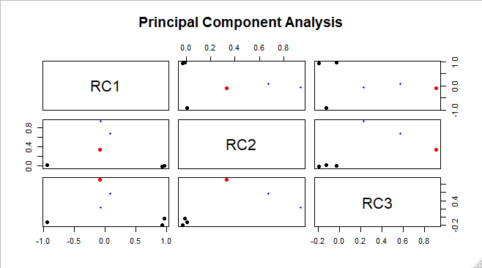

**2)**

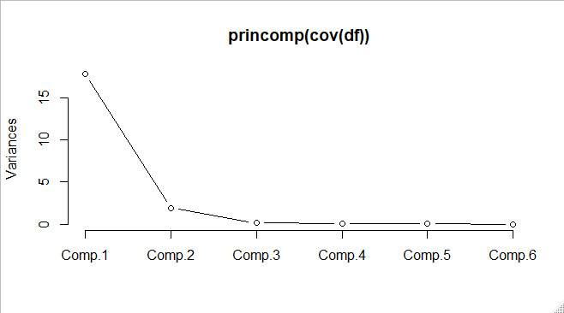

**3)**

